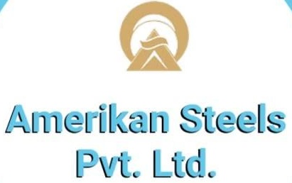

**LIST OF SPONSORS FOR WESTERN REGION CONFERENCE 2017**

Trivedi & Associates Tecknical Services (P.) Ltd. Logo Will be here

**BOOK SPONSOR:**

Shah Bhogilal’s Logo Will be here

**TEA SPONSOR:**

**CONVENTION-KIT SPONSOR:**

**SILVER SPONSOR:**

**GOLD SPONSOR:**

**LUNCH SPONSOR:**

